**Guideline for YU Exchange Program Online Application**

**1. Login** [http://std.yu.ac.kr/std/index_exch.jsp](https://apc01.safelinks.protection.outlook.com/?url=http%3A%2F%2Fstd.yu.ac.kr%2Fstd%2Findex_exch.jsp&data=05%7C01%7CNurul_Huda_Jasman%40nyp.edu.sg%7C0aaad82709a14ad2572008da9f789155%7C243ebaed00d04690a7dc75893b0d9f98%7C0%7C0%7C637997638277129820%7CUnknown%7CTWFpbGZsb3d8eyJWIjoiMC4wLjAwMDAiLCJQIjoiV2luMzIiLCJBTiI6Ik1haWwiLCJXVCI6Mn0%3D%7C2000%7C%7C%7C&sdata=lMWCJLwy5wzDYywlKCsi0RBBzc2WfiCTIOmYDgokbcc%3D&reserved=0)

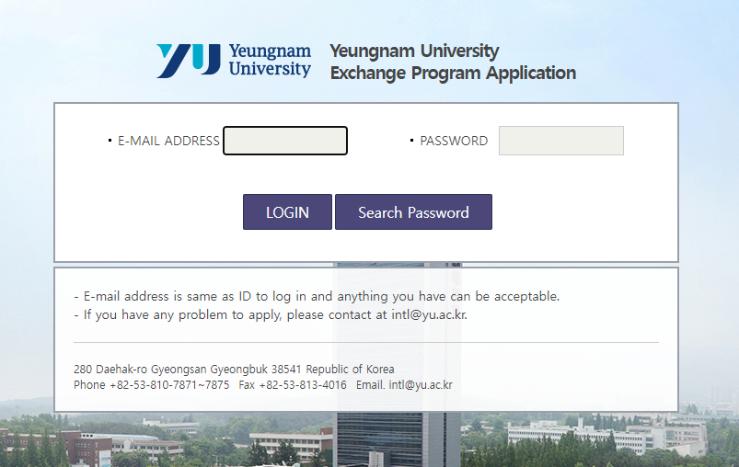

*There is a no procedure to make your account. Just entering your E-mail address and password.

**2. Check the terms**

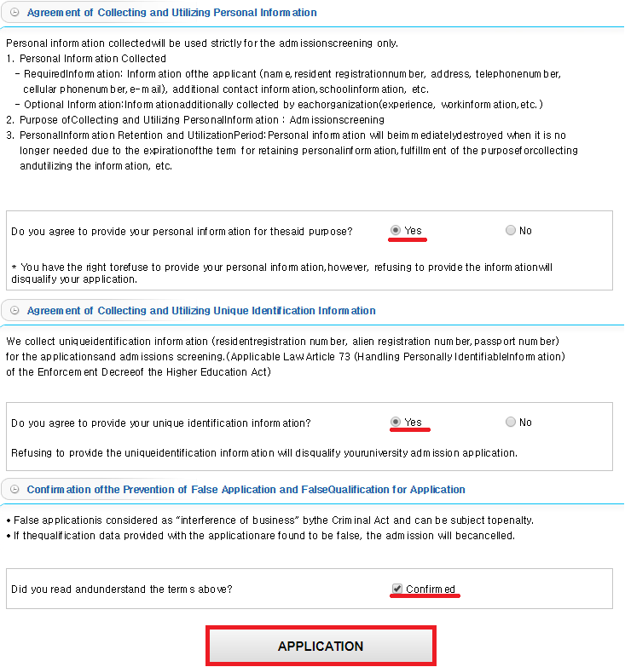

**3. Fill in your personal information**

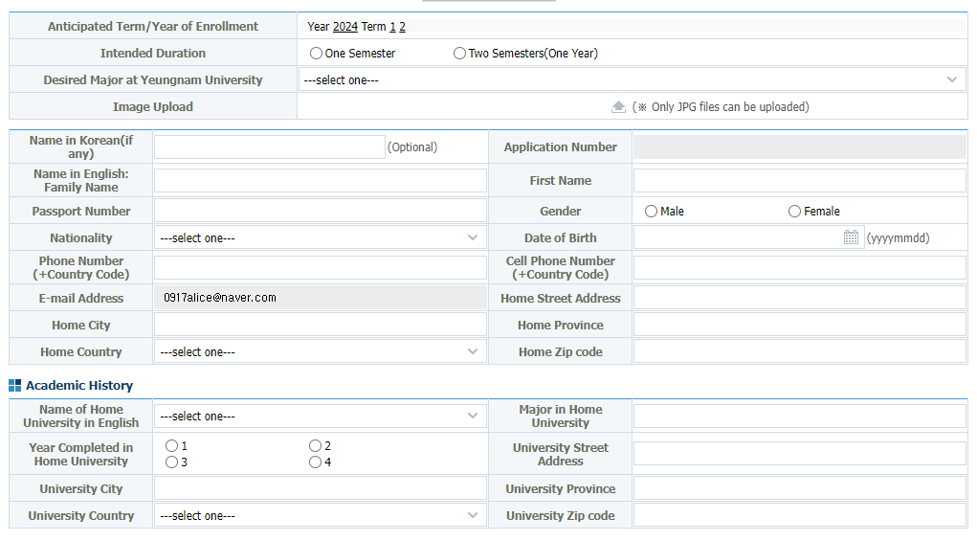

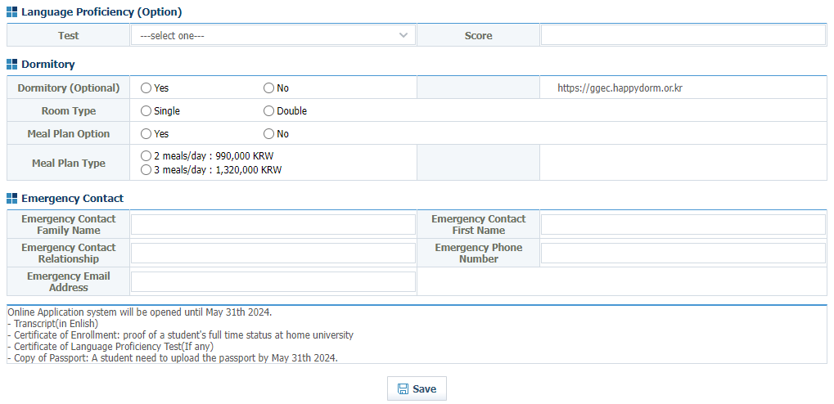

○ Intended Duration: one semester or two semesters

○ Desired Major at Yeungnam Univiersity : Please selecting your major or similar major with your home university. (You can't select the DEPARTMENT OF MEDICINE, PHARMACY AND EDUCATION)

○ You must upload your JPG Photo file.

○ Language Proficiency: Optional

○ Dormitory: PLEASE be aware that even if you choose a single room, there is a high possibility of being arranged to a double room depending on the number of international students and the situation of the dormitory.

**4. Study Plan**

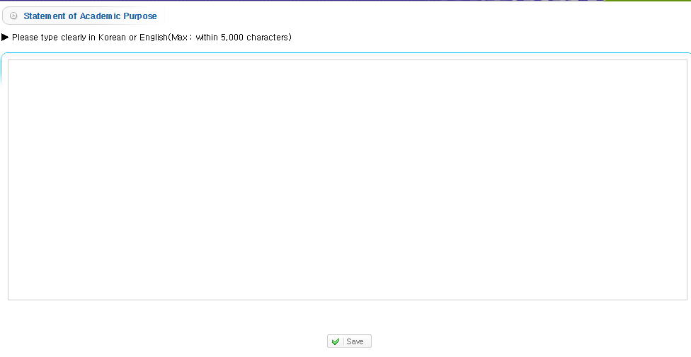

**5. Cover Letter**

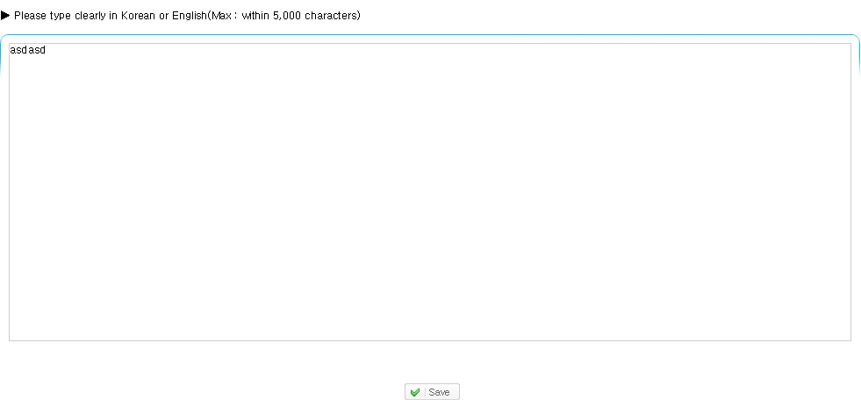

**6. Upload Documents**

○ You must upload 1. **the Transcript (in Engilsh), 2. Certificate of Enrollment(in Engilsh) and 3. Copy of Passport.**

○ You can upload only one file for one section.

**7. Submit Application**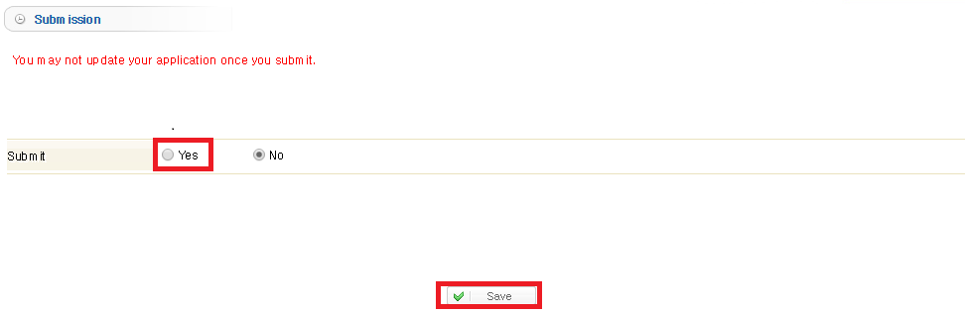

○ You can submit your application after you complete those sections.

**8. Confirm the result**

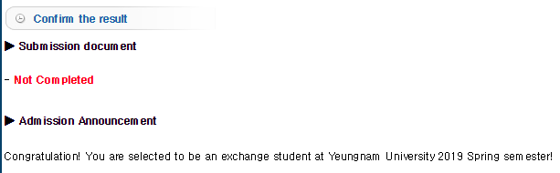

○ DO NOT WORRY about the sentence 'Not Completed'. It means our office has not checked your application yet. Your application is rightly submitted.